
GRIDNODE PTE LTD

TRANSACTION MONITORING™
Transaction Monitoring User Interface
Development Guide

Release version 1.0

TRANSACTION MONITORING™
Transaction Monitoring User Interface Development Guide

Contents

Chapter Page

1 Overview 2
1.1 Skeleton of Transaction Monitoring User Interface 2
2 Connection to Database 3
3 TXMR Configuration Setting 4
4 Workflow (Happy Flow) 5
5 ImportANT JSP Files 6
5.1 function_files/branding_setting.jsp 6
5.2 function_files/checker.jsp 6
5.3 function_files/switchpage_user.jsp 6
5.4 login.jsp 6

1 Overview
The user interface of Transaction Monitoring is done using Java Server Pages (JSP).

1.1 Skeleton of Transaction Monitoring User Interface

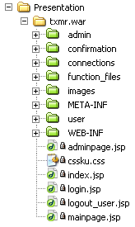

End-user related folders (user folder and admin folder)
These two folders contain mainly the business logic of the Transaction Monitoring application.

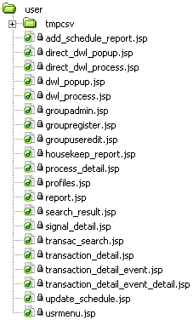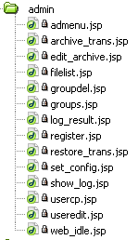

Functionality folders (function_files folder, connections folder and confirmation folder)

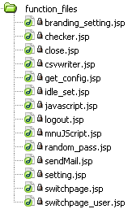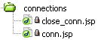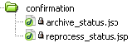

2 Connection to Database
Definition of PreparedStatement and ResultSet are done in function_files/setting.jsp.
PreparedStatement Query;
ResultSet Rs;
boolean Rs_isEmpty;
boolean Rs_hasData;

Definition of database Driver and Connection are done in connections/conn.jsp.
Driver DriverRs = null;
Connection ConnRs = null;

Closure of database Connection is done in connections/close_conn.jsp.
ConnRs.close();

An example of connection to database (function_files/idle_setting.jsp).
String queryString = "SELECT * FROM \"adm_setting\"";
Query = ConnRs.prepareStatement(queryString);
Rs = Query.executeQuery();

//Standard checking for null query
Rs_isEmpty = !Rs.next();
Rs_hasData = !Rs_isEmpty;
If(!Rs_hasData)
{ …

Note: For SELECT statement, use Rs = Query.executeQuery();.
For INSERT, UPDATE, DELETE statement, use Query.executeUpdate();.

3 TXMR Configuration Setting

Transaction Monitoring User Interface contains a configurable configuration setting by end-user (rights is only given to the Web Administrator). The file name of this configuration setting is called config.jsp. This file is not located in the txmr.war folder. It is located in:

java.lang.System.getProperty("sys.global.dir").toString() + "/GNapps/gtvan/txmr/config.jsp"

But for development purpose, config.jsp has to be placed in the locate machine, such as:
java.lang.System.getProperty("user.home").toString()+"/GridTalk/data/GNapps/gtvan/txmr/config.jsp"

Therefore, any JSP files which contain this code will need to be changed from sys.global.dir to user.home as well as the path. Those affected files are:

- index.jsp
- function_files/get_config.jsp
- admin/set_config.jsp
- admin/filelist.jsp

Note: config.jsp is reloaded every time the index.jsp is called.

4 Workflow (Happy Flow)
TXMR application starts here
index.jsp
(To check if config.jsp is loaded into function_files folder)
login.jsp
(Allow end-user to enter username and password for logging into the application)
checker.jsp
(To check if adminpage.jsp or mainpage.jsp has been closed)
adminpage.jsp
(Allow all Web Admin and Group Admin activities)
mainpage.jsp
(Allow all Group User activities)
<depends on user rights level>
Self closure
.
.
.
.
.
.
<logout user>
logout_user.jsp
(To check for session and the type of exit from the application. Example, quit.trim().equals(“true”);)
logout.jsp
(Clean session)
index.jsp

5 Important JSP Files

5.1 function_files/branding_setting.jsp
This is to allow configurable colour scheme. Colours which are using currectly are given from Inovis. Inovis has included their own cssku.css. Therefore, the GridNode cssku.css has been renamed to blue_cssku.css.

Things Inovis Added | Original naming changed to:
cssku.css | blue_cssku.css
bg (folder) | blue_bg (folder)
button_03.jpg | blue_ button_03.jpg

5.2 function_files/checker.jsp
This checker.jsp is to check whether the mainpage.jsp or adminpage.jsp has been closed.

  - function_files/switchpage_user.jsp
Due to the JSP bytes limit on each page, I’d changed all include file to static.

Instead of using <@ include file=”xxx.jsp” %> I used <jsp:include page="xxx.jsp" /> Therefore, all the xxx.jsp will need to re-import certain settings again at the beginning of the page.

  - login.jsp
End-user will not be able to auto login to TXMR if session is still valid. End-user will be logout first, then redirect to index.jsp)

